Database Initial Study

A. Situation

The purpose of the study is to develop a digital management system for the client to be able to manage their customers, payments, and services.

People Fitness Center is a gym located in White Gold Bldg. A. Soriano St. Carreta, Cebu City, The gym offers services for individuals to engage in physical activities providing a place where to pursue fitness goals. Mrs. Brenda Lee, Owner of People Fitness Center has been having difficulty keeping track of their records. Currently, the gym uses manual recording for its day-to-day operations, which can be time-consuming and cumbersome. The owner seeks alternative methods of managing the record-keeping operation, such as digital record management and better control of the records of the customers, to deter the loss of documents.

B. Problems and Constraints

Record-keeping is an essential part of the daily operations of a business, as it helps maintain accurate and reliable documentation of any activities and transactions. Additionally, record-keeping facilitates data transparency, accountability, and better decision-making. While it may seem easy, record-keeping can be a challenging task due to extensive time consumption and vast amounts of information that must be accurately managed, often prone to human errors.

The issues inferred are mentioned as follows:

* **Large space consumption within the facility:** The papers used in registration, as well as in keeping records, take up a large amount of space in the Facility.
* **Time consuming:** Manual keeping of customer data can be time-consuming especially when the recording is done through pen and paper method. Additionally, with the vast amount of paper documents stored, it would take a considerable amount of time for the management to search for a certain customer’s data.
* **Paper record-keeping:** A cumbersome method of storing data and vulnerable to human errors.
* **Data security:** Paper record-keeping is often prone to data loss.

Objectives:

The project aims to develop a better and more efficient process for keeping the records of the People Fitness Center including customer’s data, all the employees within a gym, as well as the transactions performed for the membership.

Specific Objectives:

Develop a digital management system where the user can:

1. Check customer’s information and their choice of service.
2. Track customer’s status whether they are expired or still active.
3. Add, update, and delete customer accounts, employees, and services.
4. Tracks transaction history of a customer.

D. Scope and Boundaries

Scope

The scope of this project includes the people who work in the People Fitness Center, its customers, and the owner who serves as the administrator.

Boundaries

* The system does not include ONLINE payment methods.
* The system only accommodates monthly membership registrations

Functionalities

The following are the functionalities of the system:

* A dashboard where you can see the updated notification and lists about customer’s membership status
* Registration for customers with their personal details and choice of service.
* Displays the list of members according to their personal information and edits the details when necessary.
* Displays the list of membership status and renews customer’s service.
* Displays the list of transaction history.
* Display the list of services and can edit or add new service with the price
* Displays the table of employees with their information

Database Design

A. CONCEPTUAL DESIGN

BUSINESS RULES

* A SERVICE IS ASSOCIATED IN ONE OR MANY MEMBERSHIP
* ONE OR MANY MEMBERSHIP HAS ONLY ONE SERVICE
* A MEMBER CAN HAVE ONE OR MANY MEMBERSHIP
* ONE OR MANY MEMBERSHIP HAS A MEMBER
* EACH MEMBERSHIP GENERATES ONLY ONE TRANSACTION
* A TRANSACTION IS GENERATED BY ONLY ONE MEMBERSHIP
* 0 OR ONE EMPLOYEE ASSISTS 0 OR MANY MEMBERS
* 0 OR MANY MEMBERS IS ASSISTED BY 0 OR ONLY ONE EMPLOYEE

Entity Relationship Diagram (ERD)

EXTERNAL MODEL

SERVICE - a set of workout routines offered by the management.

MEMBERS - a person who signs-up for a membership to avail the service offered by the management.

MEMBERSHIP - a record of registered members with their chosen service, and their status of membership.

TRANSACTION - a record of completed transaction.

EMPLOYEE - a person who manages the establishment and provides assistance to the members.

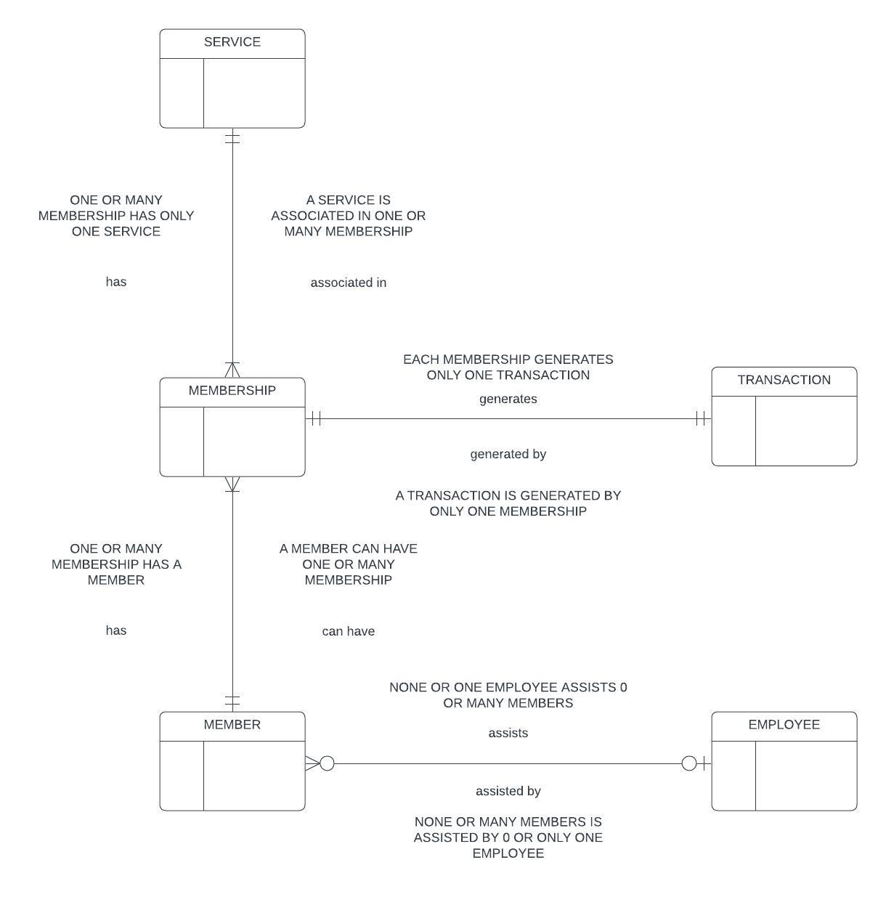

Conceptual Model

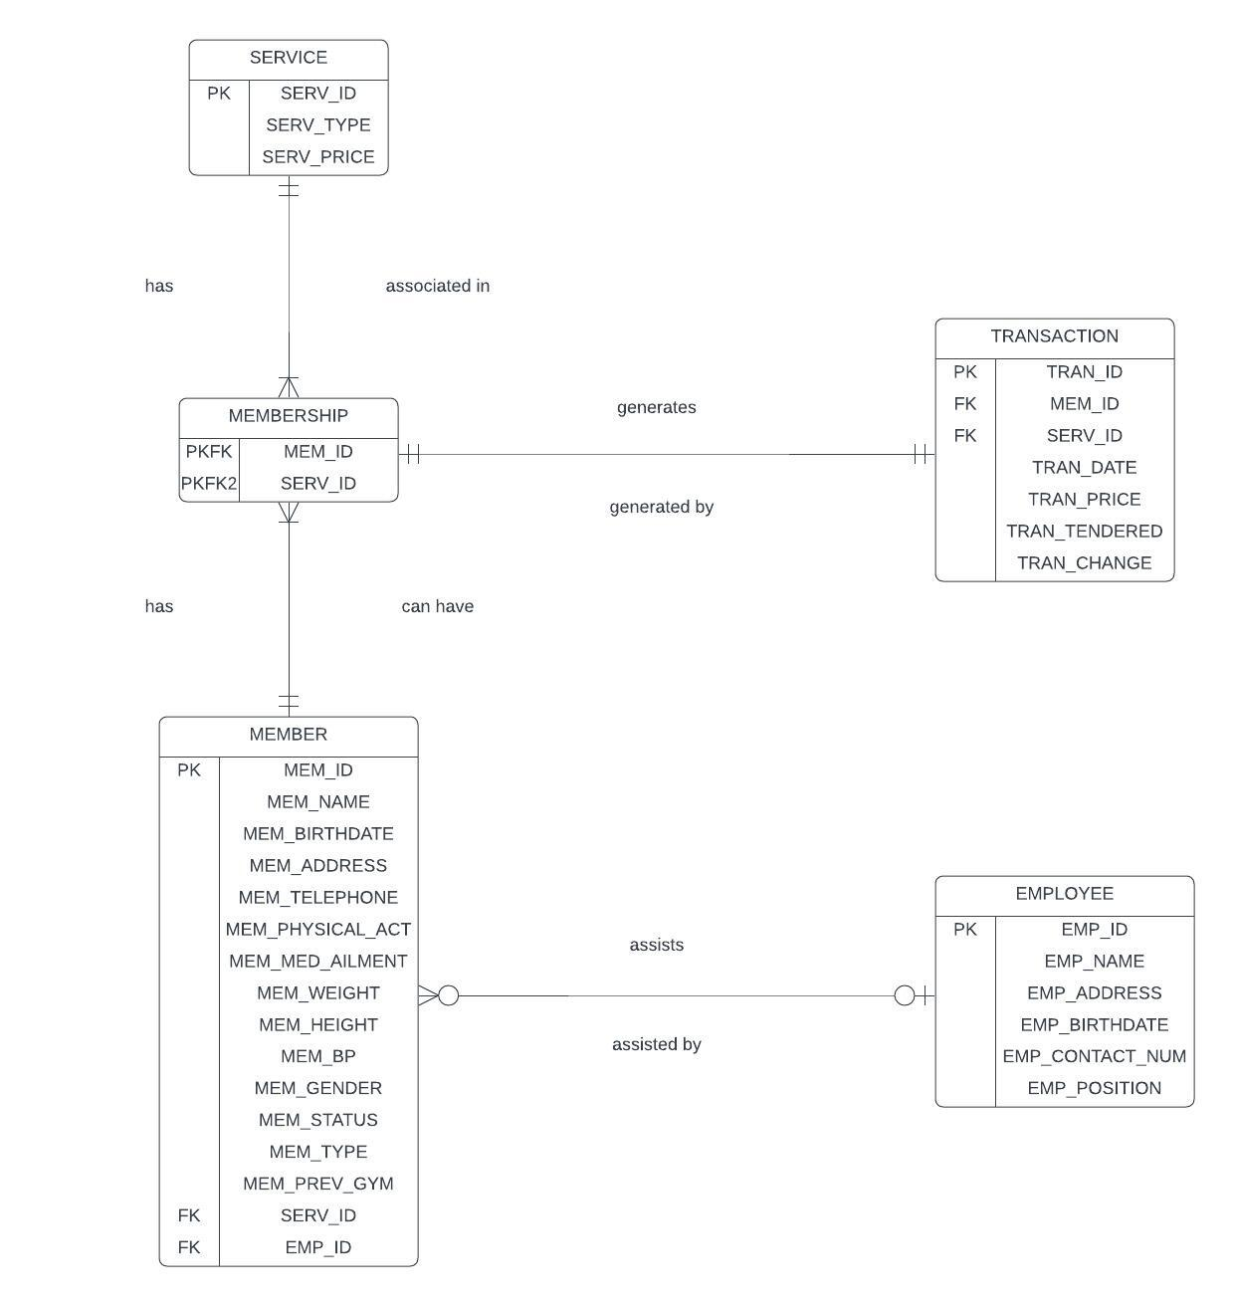

Extended Entity Relationship Diagram (EERD)

Data Dictionary

B. DBMS Selection

PostgreSQL, often referred to simply as Postgres, is an advanced open-source relational database management system (RDBMS). It's known for its reliability, robustness, and extensive feature set. Originally developed at the University of California, Berkeley, PostgreSQL has since evolved through the collaborative efforts of a global community of developers.

As an RDBMS, PostgreSQL stores and manages data in a structured format, using tables with rows and columns. It adheres to the SQL (Structured Query Language) standard, allowing users to interact with the database using SQL queries for tasks such as data insertion, retrieval, updating, and deletion.

The reason why we chose PostgreSQL as our DBMS is due to its open-source nature, robustness, and reliability, adhering to ACID principles, ensuring data integrity even in high-volume transactional scenarios. Its extensible architecture allows for customization with custom data types, functions, and procedural languages, while advanced features like full-text search, JSON support, and geospatial capabilities cater to modern application needs. PostgreSQL scales efficiently, supporting large datasets and high traffic loads through features like replication and partitioning, and prioritizes security with SSL encryption, role-based access control, and authentication mechanisms. It's cross-platform compatible, running on various operating systems, and benefits from a vibrant community of developers who contribute to its ongoing development, support, and optimization, ensuring performance even in demanding environments.

C. Logical Design

Internal Model

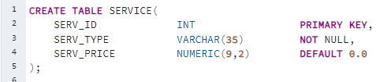

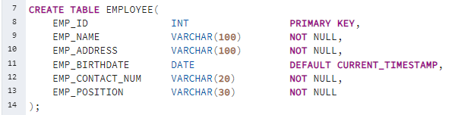

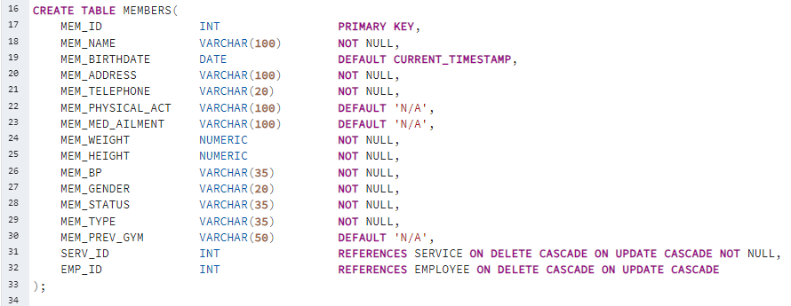

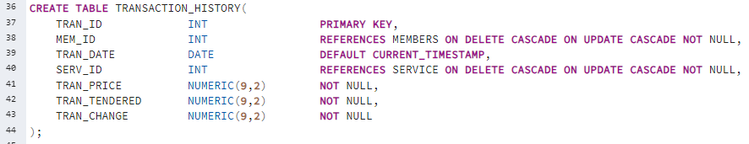

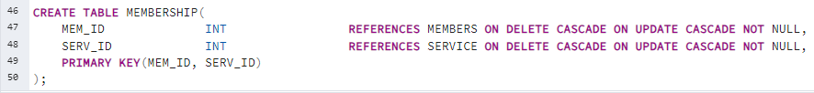

Physical Model

D. Physical Design

1. Prototype